Maximillian Burrell

Z749D638

EE595: SPD2

F ,12:30 PM-2:15PM

Safety Requirements

Warning: Each device is electrostatic sensitive and requires caution per installation. ESD safe PPE (personal protective equipment) is recommended.

3.7 Volts for total system power

*Components*

* Arduino MKR WAN 1310 Sensor (104 micro-amperes)
* TIme-of-flight sensor (3 to 7 micro-amperes, usually 5 on average)
* Magnetometer (3 micro-amperes)
* Solar Panel (60 mm x 30 mm)
* 4000 mA battery for system power

Each device will be represented per installation with pictures below

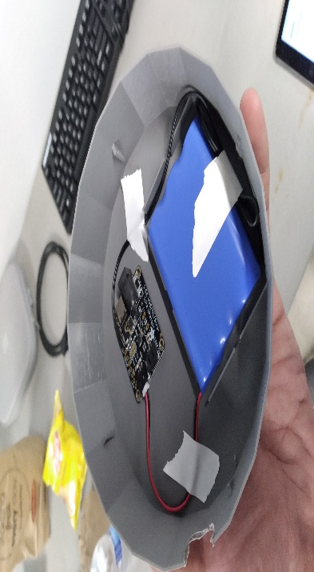

While wearing ESD safe gloves, the battery and charging unit will be placed at the bottom of the enclosure. They will sit below the sensor package for optimal heat dissipation.

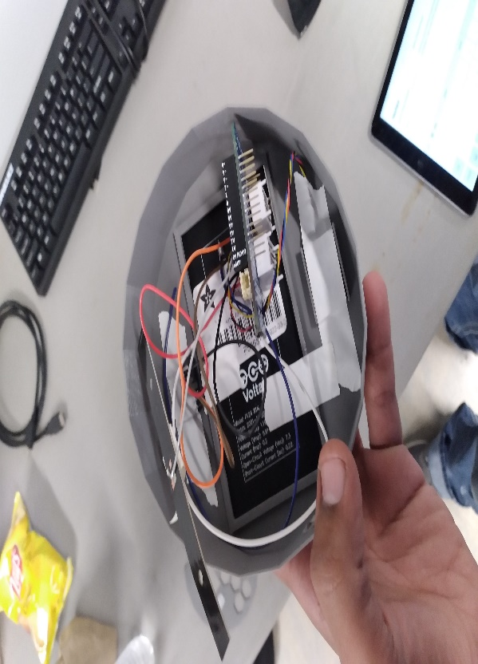

The sensors will sit above the power solution. There is a divider separating the internal components. That way internal heat can escape and each sensor may work appropriately with little to no interference. The software applications will be worked out by the CS Team.

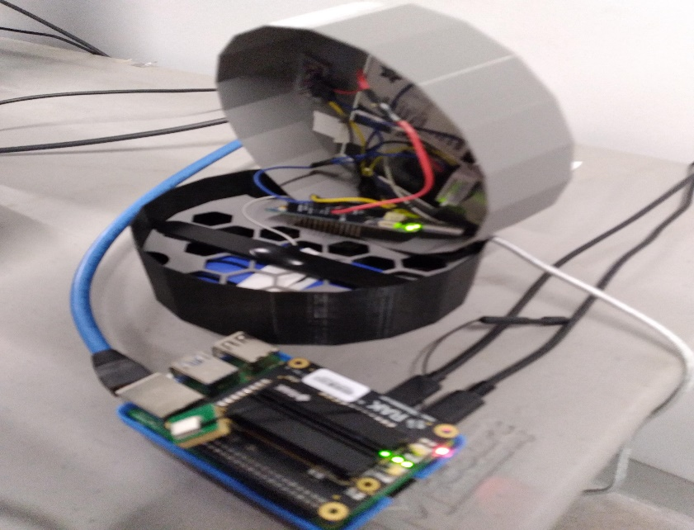

After installation, use ESD safe gloves to assemble the enclosure with the fitted components. Each device is pictured for reference in this document. Wearing grounded clothing is recommended to protect the components from ESD damage.

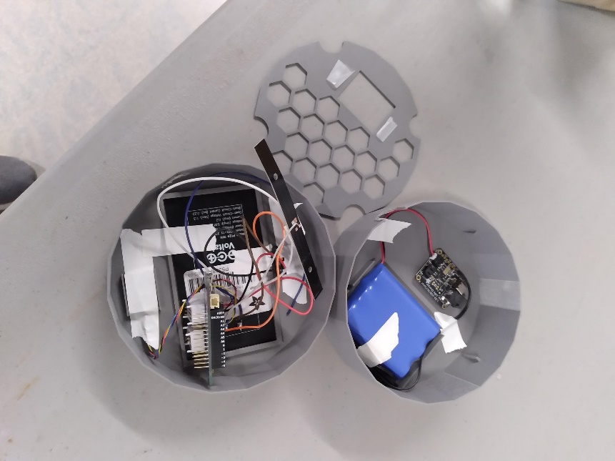

Once the unit is assembled, it is ready to be programmed for application. Energy consumption, in amperes, will be provided.

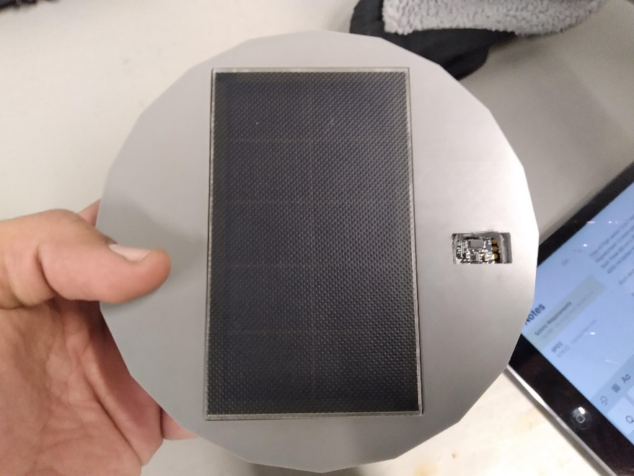

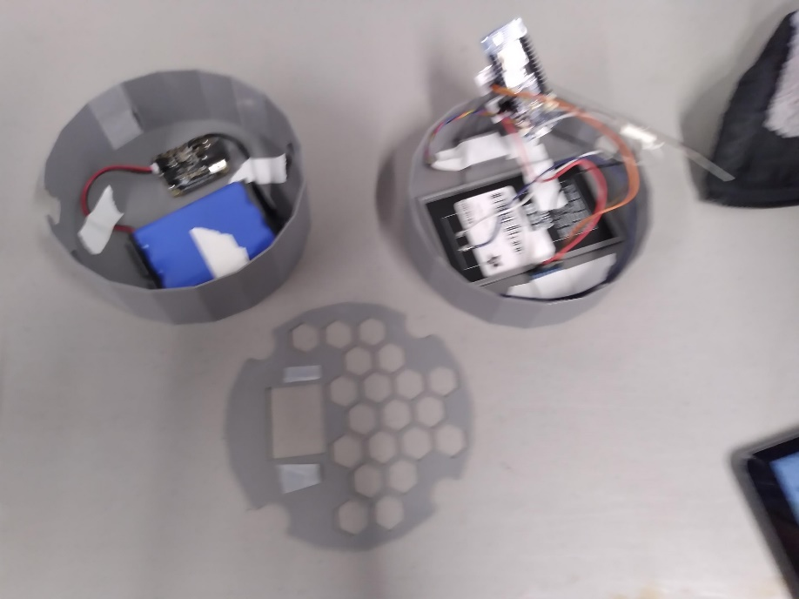

Note: Another Frame of Reference, Research From 10_23_21 addresses each elements power consumption.